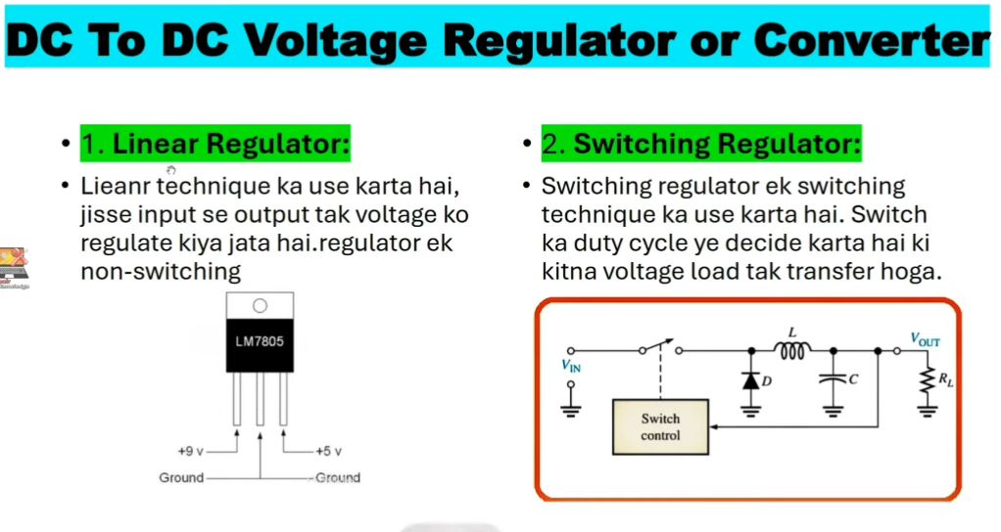
Linear me hume Fix voltage milta hai
But Switching Regulator me hume flexible (kam/jyda) kr sakate hai

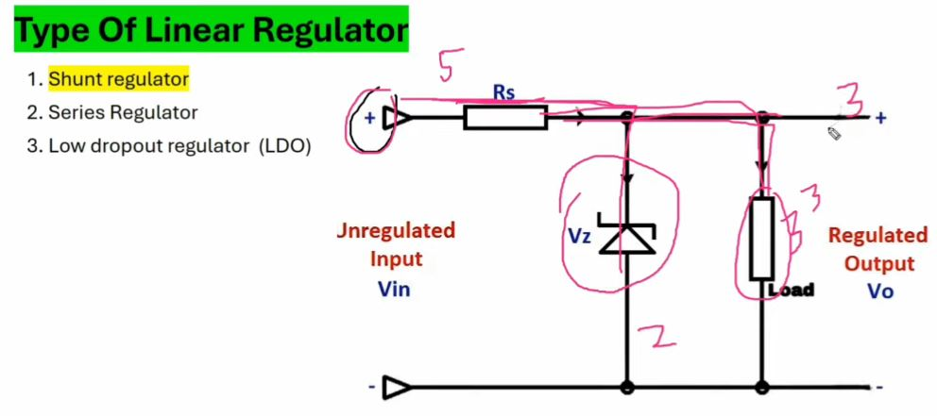

Zener Diode 2 volt ko ground kr dega aur 3 volt stable voltage dega.
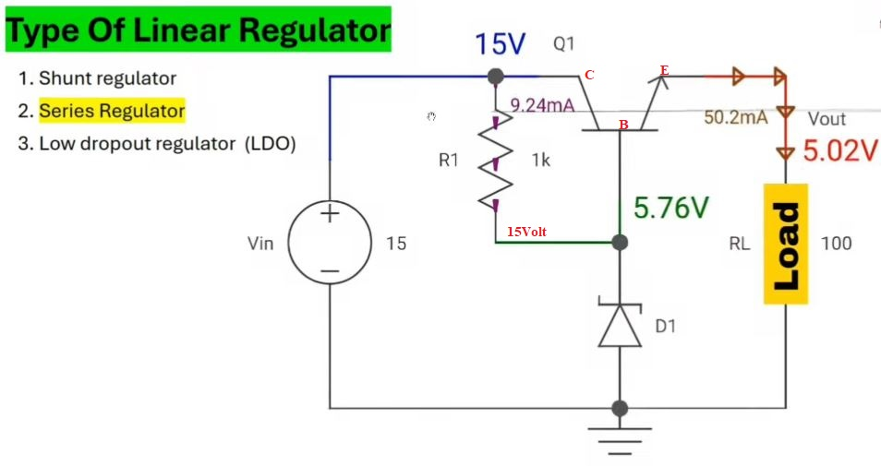

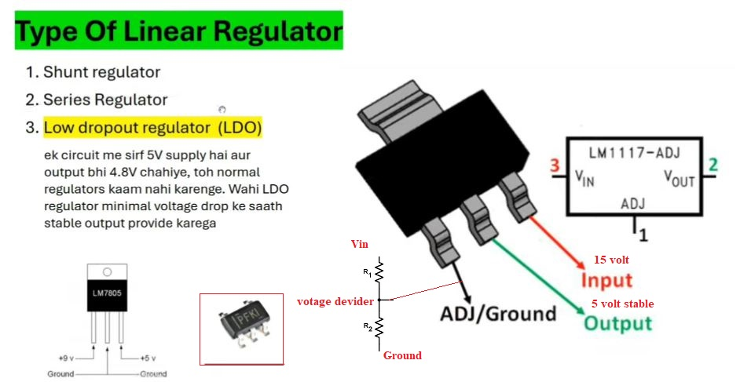
Kabhi kabhi dim display ke liye bhhi LDO failure hota hai.

Switching Regulator
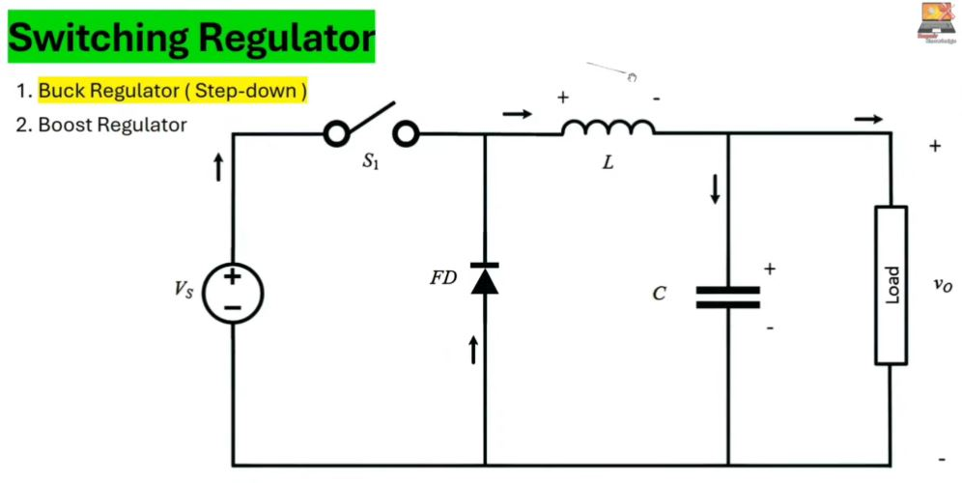

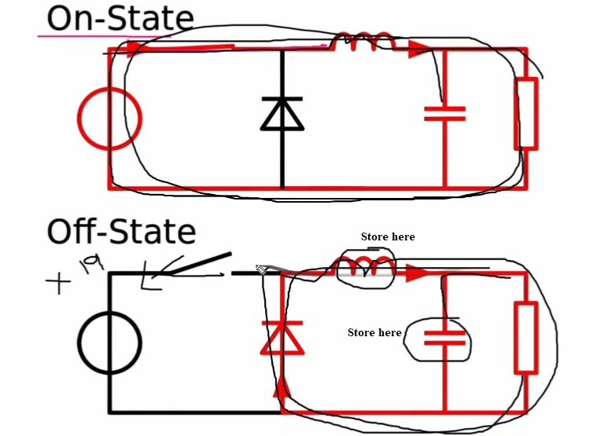
Note: switch S1 on/off hota hai jis se voltage generate hoti hai.
Step down IC – high voltage 15 volt in hua and low voltage 10 out hua

